Style Guidelines for Final Year Project ReportsEarly intervention model At risk using predictive analysis
Final Year Project



Supervisor: <MUSTAFA HAMEED>

Presented by:
F22BINFT1M01174 NOOR FATIMA


Department of Information Technology (DIT)

The Islamia University Of Bahawalpur
Topic of Project

Early intervention model At risk using predictive analysis

By

NOOR FATIMA

Project submitted to

Department of Information Technology,

The Islamia University of Bahawalpur.

in partial fulfillment of the requirements for the degree of

BACHELOR OF SCIENCE
IN
INFORMATION TECHNOLOY (BSIT)

Supervisor Signature | In- Charge Examination Signature

Chairman, Department of Information Technology

ABSTRACT

The Early Intervention Model for At-Risk Individuals Using Predictive Analysis is an intelligent system designed to identify students who may face academic, behavioral, or engagement-related challenges. Traditional monitoring methods rely heavily on manual observation and often detect problems after they have become severe. This project utilizes machine learning and predictive analytics to identify risk factors at an early stage, enabling timely intervention and support.

The system collects data from multiple sources, including attendance records, academic performance, behavioral reports, and engagement metrics. Through preprocessing, feature engineering, and predictive modeling, students are classified into Low-Risk, Medium-Risk, and High-Risk categories. Automated alerts are generated for counselors and administrators, allowing them to take proactive measures.

The implementation uses React.js for the frontend, Django for the backend, MySQL as the database, and machine learning algorithms such as Random Forest, Decision Tree, and XG Boost. Experimental results demonstrate high prediction accuracy and improved monitoring efficiency. The system contributes to better student retention, academic success, and institutional decision-making.

Keywords: Predictive Analytics, Machine Learning, Educational Data Mining, Early Warning System, Risk Prediction.

ACKNOWLEDGEMENT

I would like to express my sincere gratitude to Almighty Allah for granting me the strength, patience, and guidance to complete this Final Year Project successfully.

I am deeply thankful to my supervisor, Dr. Mustafa Hameed, for his valuable guidance, encouragement, and continuous support throughout the project. His expert advice and constructive feedback played a vital role in the successful completion of this work.

I also extend my appreciation to the faculty members of the Department of Information Technology, The Islamia University of Bahawalpur, for providing the knowledge and resources necessary for this project.

Finally, I would like to thank my family and friends for their constant motivation, support, and encouragement throughout my academic journey.

LIST OF FIGURES

Figure 1: System Architecture

Figure 2: Context Diagram

Figure 3: Use Case Diagram

Figure 4: DFD Level 0

Figure 5: DFD Level 1

Figure 6: ER Diagram

Figure 7: Activity Diagram

Figure 8: Sequence Diagram

Figure 9: Component Diagram

Figure 10: Deployment Diagram

Figure 11: Machine Learning Workflow

Figure 12: Dashboard Interface

LIST OF TABLES

Table 1: Existing System Comparison

Table 2: Functional Requirements

Table 3: User Roles and Permissions

Table 4: Test Cases

Table 5: Evaluation Metrics

Table 6: Model Performance Results

CHAPTER 1:

INTRODUCTION

Introduction

Educational institutions continuously face challenges in identifying students who are at risk of academic failure, poor engagement, or behavioral issues. Early identification is crucial because delayed intervention often results in reduced academic performance and increased dropout rates.

The advancement of machine learning and predictive analytics provides an opportunity to detect risk factors before problems become severe. By analyzing historical and real-time educational data, institutions can proactively support students and improve overall educational outcomes.

This project introduces an Early Intervention Model that integrates machine learning algorithms with educational data analytics to identify at-risk individuals and facilitate timely interventions.

Objectives

Identify at-risk students using predictive analytics.

Analyze attendance, grades, and behavioral indicators.

Generate automated alerts.

Assist counselors in intervention planning.

Provide analytical dashboards and reports.

Improve student retention and performance.

1.3 Problem Statement

Current educational systems lack predictive mechanisms to identify students who may face academic or behavioral challenges. As a result, interventions occur after significant issues have already developed. The proposed system addresses this gap by using machine learning to predict risk levels and support proactive decision-making.

1.4 Scope

The project focuses on:

Attendance Monitoring

Academic Performance Analysis

Behavioral Tracking

Engagement Analysis

Risk Prediction

Alert Management

Dashboard Reporting

1.5 Significance of the Study

The project improves educational support systems by enabling institutions to identify risk factors early and provide targeted interventions.

1.6 Limitations

Requires digital educational records.

Depends on data quality.

Limited to educational environments.

CHAPTER 2:

REQUIREMENTS ANALYSIS

2.1 Literature Review

Early Warning Systems

Early Warning Systems are widely used to identify students requiring additional support. Most systems focus only on attendance and academic performance.

Learning Analytics

Learning analytics helps institutions understand student behavior through data analysis.

Predictive Analytics in Education

Predictive analytics uses machine learning models to forecast future student outcomes.

Research Gap

Existing systems:

Use limited data sources.

Lack automated intervention mechanisms.

Provide limited predictive capabilities.

Proposed Solution

The proposed model integrates:

Multi-dimensional data analysis

Predictive modeling

Automated alerts

Intervention management

2.2 User Classes and Characteristics

Student

Views personal risk status and recommendations.

Counselor

Monitors risk levels and records interventions.

Administrator

Manages users and system settings.

Management

Accesses reports and analytics.

2.3 Design and Implementation Constraints

Internet connectivity required.

Availability of educational datasets.

Compliance with privacy regulations.

Hardware resource limitations.

2.4 Assumptions and Dependencies

Educational records are available digitally.

Users have authorized access.

Machine learning libraries are available.

2.5 Functional Requirements

FR001 User Registration

FR002 Login Authentication

FR003 Data Collection

FR004 Risk Prediction

FR005 Alert Generation

FR006 Intervention Tracking

FR007 Reporting and Analytics

2.6 Use Case Diagram

Include UML Use Case Diagram.

2.7 Non-Functional Requirements

Performance Requirements

Support 200+ concurrent users.

Security Requirements

Password encryption

Role-based access control

Secure authentication

Reliability Requirements

99% uptime with backup support.

Scalability Requirements

Support multiple departments and academic years.

CHAPTER 3: SYSTEM DESIGN

3.1 Application and Data Architecture

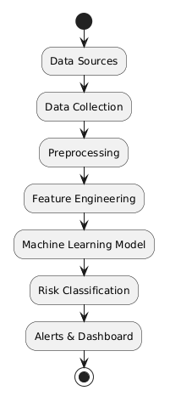
System Architecture Diagram

ER Diagram
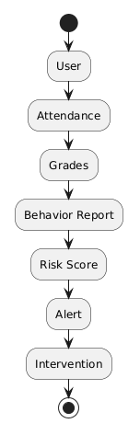

Class Diagram
Include UML

3.2 Component Interactions and Collaborations

Sequence Diagram
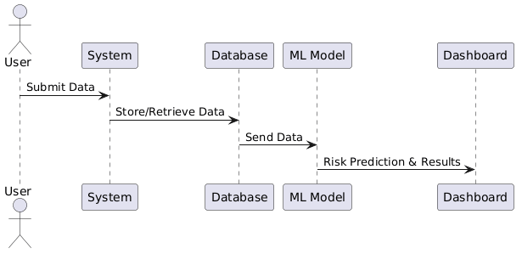

Activity Diagram

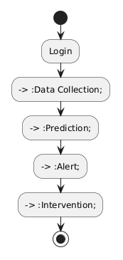

DFD Level 0

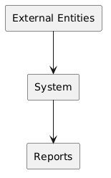

DFD Level 1

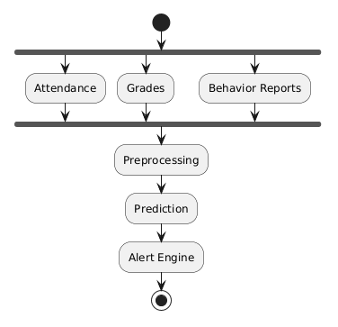

3.3 System Architecture

Frontend

React.js

Backend

Django

Database

MySQL

Machine Learning Layer

Scikit-Learn Models

3.4 Architecture Evaluation

Why React.js?

Fast rendering

Component reusability

Why Django?

Security

Rapid development

Why MySQL?

Reliability

Scalability

Why Random Forest?

High accuracy

Reduced overfitting

3.5 Component External Interfaces

User Interface ↔ Backend API

Backend ↔ Database

Backend ↔ Machine Learning Module

3.6 Screenshots / Prototype

Login Page

Dashboard

Risk Analysis Screen

Reports Screen

Alert Screen

3.7 Other Design Details

Feature Engineering Process

Risk Score Formula

Prediction Pipeline

CHAPTER 4: TEST SPECIFICATION AND RESULTS

4.1 Test Cases
Test Case ID | Description | Expected Result
TC001 | Login | Successful Login
TC002 | Risk Prediction | Risk Generated
TC003 | Alert Notification | Alert Sent
TC004 | Report Generation | Report Created

4.2 Summary of Test Results

Evaluation Metrics
Metric | Value
Accuracy | 92%
Precision | 90%
Recall | 89%
F1 Score | 89.5%

Confusion Matrix

Accuracy Graph

Feature Importance Graph

CHAPTER 5: CONCLUSION AND FUTURE WORK

5.1 Project Summary

The proposed system successfully predicts at-risk students using machine learning and predictive analytics. It improves monitoring efficiency and enables timely interventions.

5.2 Problems Faced and Lessons Learned

Problems Faced

Data collection challenges

Missing values

Model tuning difficulties

Lessons Learned

Importance of data quality

Feature engineering techniques

Machine learning model optimization

5.3 Future Work

Deep Learning Integration

Mobile Application Development

Real-Time Prediction

AI Counseling Assistant

Cloud Deployment

REFERENCES

APPENDIX A: GLOSSARY

ML – Machine Learning

AI – Artificial Intelligence

EWS – Early Warning System

RBAC – Role-Based Access Control

F1 Score – Harmonic mean of Precision and Recall

APPENDIX B: DEPLOYMENT GUIDE

Install Python

Install Django

Install MySQL

Install Required Libraries

Configure Database

Run Migrations

Start Django Server

Access System Through Browser

